AltWheels Fleet Day 2026
Speaker & Participant Bios
Monday, October 5, 2026 • Four Points by Sheraton • Norwood, Massachusetts

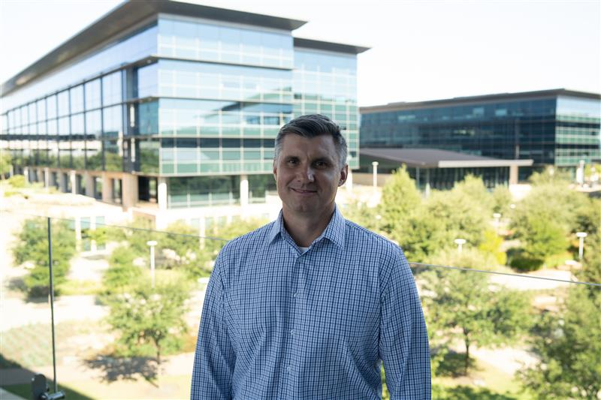 | Egor Agafonov  Business Development, Northeast  Toyota Motor North America
Egor Agafonov joined Toyota Motor North America 10 years ago. He spent seven years working with dealers on the retail side in the Kansas City Region, and for the past three years has been with the Fleet division. He is currently responsible for business development in the Northeast.
________________________________________________________________________________
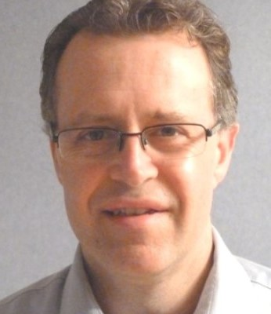 | Matthew Austin  Business Development & Ecosystem Partnerships  Viatec, Inc.
Matthew Austin heads up business development and ecosystem partnerships for Viatec, Inc., a leading provider of fleet electrification solutions for medium- and heavy-duty vehicles at job sites. Prior to Viatec, he led sales and marketing campaigns for several technology innovation start-ups in telecommunications, ecommerce, and enterprise software. His focus is on building effective partnerships that collectively make a tangible economic and sustainable impact on vocational and transportation applications in public and private sector fleets.
________________________________________________________________________________
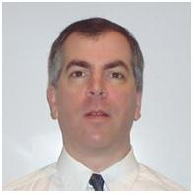 | Peter Beloli  Fleet Management Professional
Peter Beloli is a fleet management professional with more than 25 years of experience managing both service van fleets and pharmaceutical sales fleets. He is well-versed in coordinating with fleet management companies (FMCs) and original equipment manufacturers (OEMs).
Peter served as Chair of the local NAFA New England Chapter for five years and was a member of the GE Capital Client Advisory Board for four years.
________________________________________________________________________________

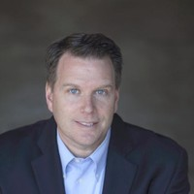 | Scott Bradley  Director of Sales and Strategic Partnerships  Pioneer eMobility
Scott Bradley is an enthusiastic and devoted electric vehicle (EV) advocate. His areas of expertise encompass EV charging and EV charging infrastructure. Scott has more than a decade of experience working in and exploring technology and energy industries, and is often invited to speak at national events, focusing on forward-thinking topics such as off-grid EV charging and the future of the grid.
Scott sustains a deep academic interest in the evolution of electric vehicles, researching their history, development, impact on society, and the evolution of transportation. His hands-on experience with leading brands and technologies, coupled with his passion for his work, drives him to explore ways to innovate and improve the EV experience. Scott is committed to advancing the industry and contributing to a sustainable future. He holds a B.S. in Electrical Engineering and an M.S. in Electrical Engineering - Robotics and Artificial Intelligence.
________________________________________________________________________________
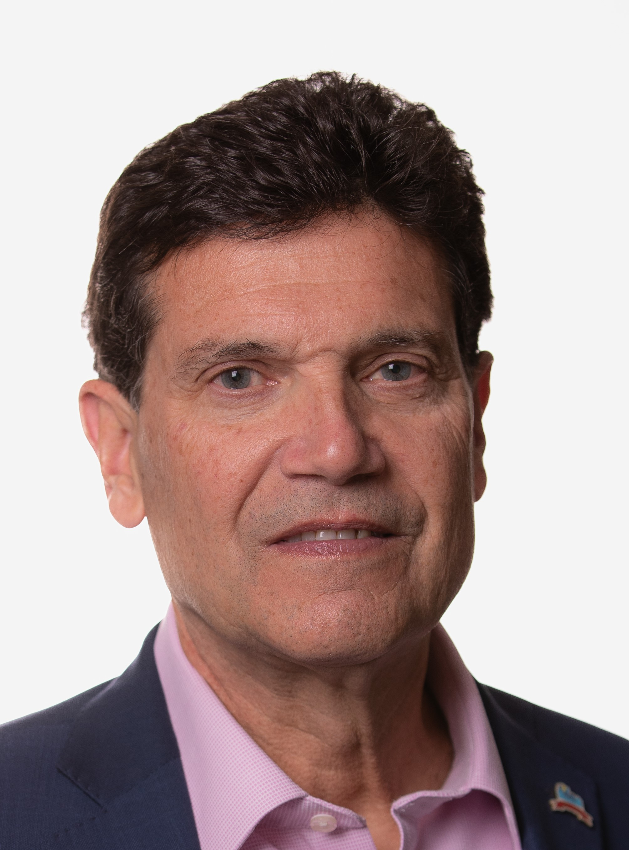 | Barry Carr  Director  Clean Communities of Central New York
Barry Carr has spent his career in the advanced transportation world, working with major utilities, governments, and fleets to develop clean transportation programs including EVs and EV charging, natural gas, renewable natural gas, propane, and hydrogen. For more than 20 years, Barry has served as Director for Clean Communities of CNY, the U.S. Department of Energy's Clean Cities and Communities Partnership housed at the Syracuse Center of Excellence. In this role, he advises both public and private groups on transportation decarbonization and serves as a project manager for state- and federally funded clean transportation projects.
Barry serves on the Federal and State Government Advocacy Committees for the Transport Project, the Avangrid Community Advisory Board, and the Transportation Energy Partners board, and is an advisor to the NYS Clean Transportation Prize. He has received several lifetime achievement awards from industry organizations and the U.S. Department of Energy. Barry is also a board member of Empire Clean Cities, Greater New Haven Clean Cities, and Capital Clean Cities of Hartford, Connecticut.
________________________________________________________________________________
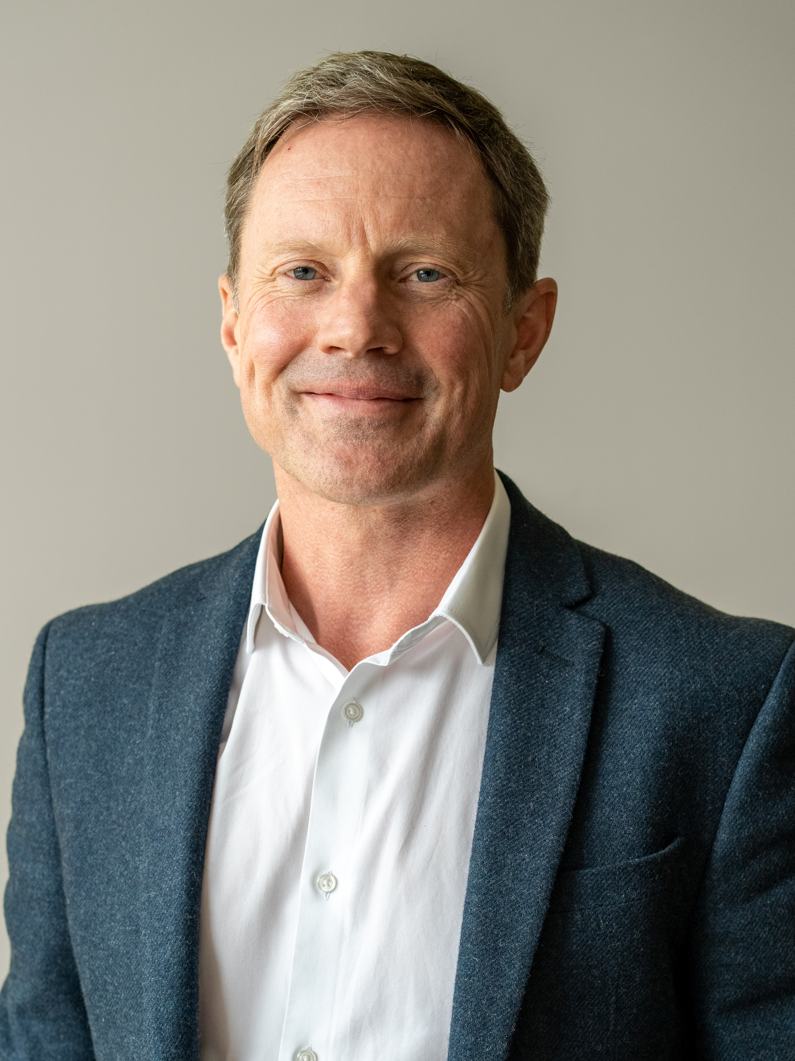 | Ralph Clague  Chief Development and Operations Officer, Energy Solutions  Hyster-Yale Materials Handling, Inc.
Ralph Clague leads product development, innovation, and operations for the Energy Solutions Group at Hyster-Yale Materials Handling, Inc., where he is responsible for advancing next-generation hydrogen fuel cell technologies and zero-emission power systems that address real-world customer and market needs. His leadership spans the full product lifecycle, from advanced research and system architecture through pre-production and commercialization.
Ralph brings more than 20 years of experience in low- and zero-emission powertrains, with deep technical expertise and executive leadership focused on hydrogen and fuel cell systems. Most recently, he served as Head of Hydrogen and Fuel Cells at Jaguar Land Rover, where he led strategic hydrogen initiatives for future mobility. Earlier in his career, he held senior roles at Intelligent Energy Ltd., Great Wall Motor in China, McLaren, and Gordon Murray Design, and began his career as an engine designer for passenger vehicles and Formula 1.
He holds a B.S. in Physics, an M.S. in Advanced Mechanical Engineering, and a Ph.D. from Imperial College London.
________________________________________________________________________________
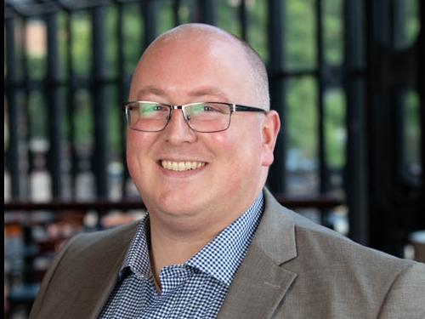 | Zach Gilbert  Fleet Advisor  Enterprise Fleet Management
Zach Gilbert is a Fleet Advisor with more than 15 years of experience with Enterprise, helping companies across New England reduce fleet costs and improve operations through strategic guidance, technology solutions, and hands-on fleet expertise.
________________________________________________________________________________
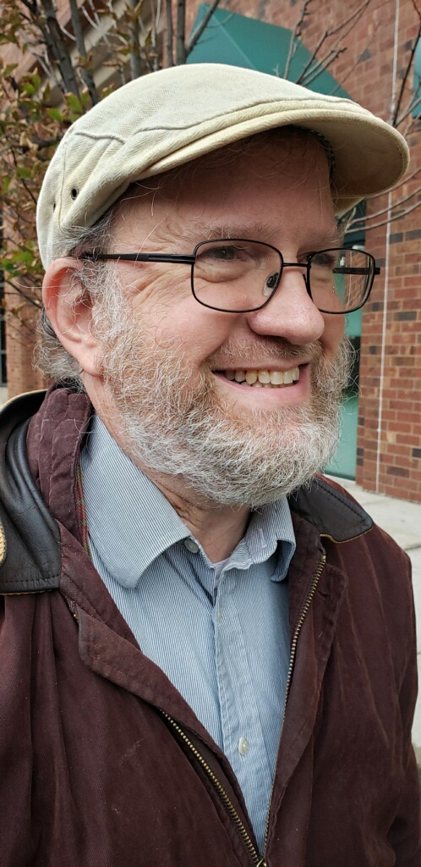 | Ronald Gitelman  Fleet Coordinator  Yale University
Ronald Gitelman is Fleet Coordinator at Yale University. Raised in Fayetteville, Arkansas, he received a B.S. in Business Administration with a major in Accounting from Louisiana State University Baton Rouge in 1985 and received an MBA and MPA from the University of New Haven in 2010.
He started working at Yale in 2002 as a departmental administrator before moving into fleet management in spring 2011. Over the past 15 years, he has built a world-class fleet organization and worked to create efficiencies in fleet using systems in place and new technologies. This continues today, including a major project underway to right-size the Yale fleet and expand vehicle sharing to maximize vehicle utilization over the next several years.
Over the past 15 years, Yale's fleet has expanded its alternative-fuel vehicles so that today the university fleet contains 75 hybrid vehicles, 24 propane or bi-fuel propane vehicles, and 13 electric vehicles. Ronald works with the Yale Sustainability Office to ensure the fleet is in compliance with Yale's sustainability goals. He recently became President of the National Alliance of State and University Fleets after serving as Director of Strategy and President-Elect, and in 2028 will move into the past-president role.
________________________________________________________________________________
 | Lindsay Herneisen  Commercial Energy Sales Manager, GM Fleet - Northeast & Southeast  General Motors
Lindsay Herneisen is the Commercial Energy Manager at General Motors, specializing in fleet electrification, EV charging strategy, and sustainable transportation solutions for commercial and public-sector organizations. With nearly 15 years of experience across the cleantech and automotive sectors, Lindsay continues to help fleets transition from internal combustion to electric through data-driven planning, operational readiness, and long-term energy strategy.
Lindsay's background includes leadership roles at Tesla and ChargePoint, where she successfully led sales teams to support large-scale infrastructure deployments and helped organizations build resilient, future-ready electrification programs. Lindsay is passionate about accelerating the adoption of clean transportation and empowering organizations to meet their sustainability goals through smart, scalable energy solutions.
________________________________________________________________________________
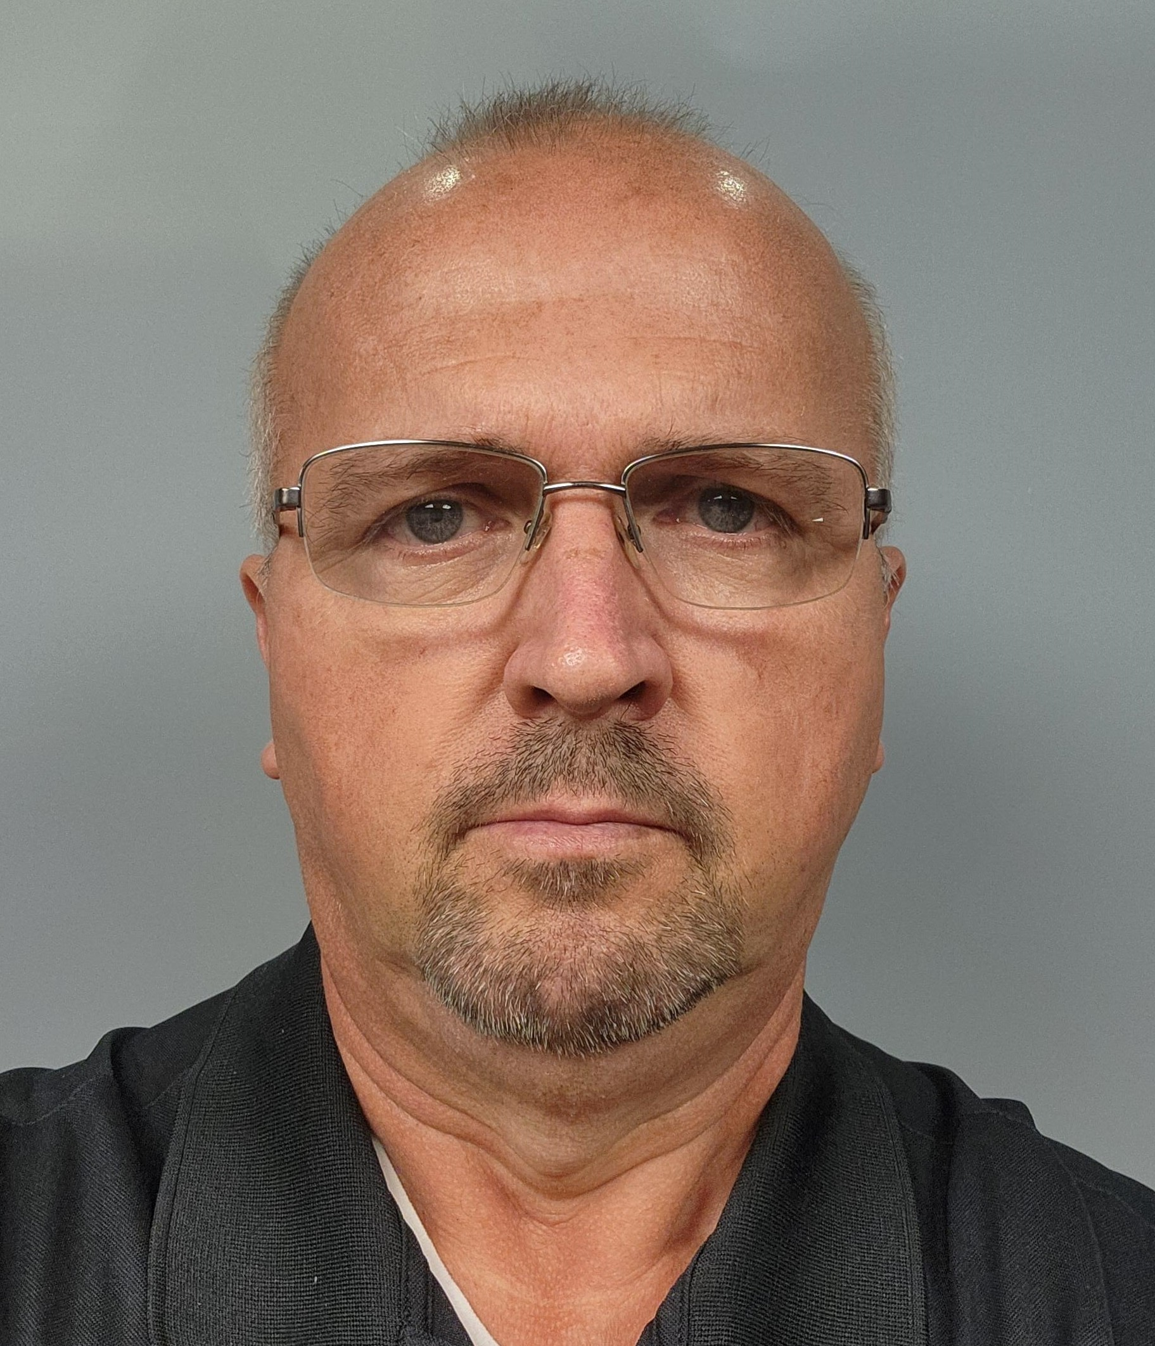 | John Keeter  Fleet Manager  City of Cambridge, Massachusetts
John Keeter is an experienced fleet professional with 30 years of experience at various levels, from Technician to Fleet Manager in public-sector fleets. He is currently the Fleet Manager for the City of Cambridge, Massachusetts. He holds a Bachelor's Degree in Public Administration from Southern New Hampshire University (2017), as well as a Master's in Operations and Project Management from Southern New Hampshire University (2019).
Throughout his 30 years in the industry, his focus has leaned toward implementation of fleet electrification and upgrading the use of technology in fleet operations. In his spare time, he volunteers with veterans organizations and coaches youth soccer.
________________________________________________________________________________
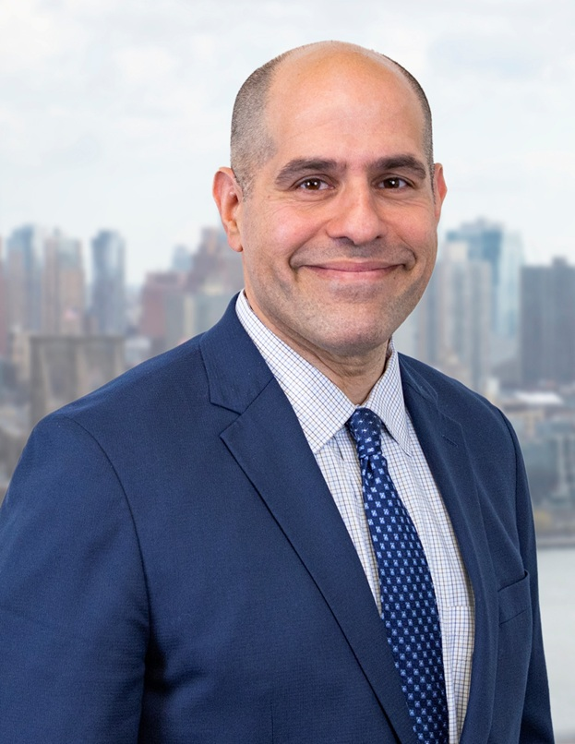 | Keith Kerman  Deputy Commissioner, DCAS & Chief Fleet Officer  City of New York
Keith Kerman is a Deputy Commissioner at the Department of Citywide Administrative Services (DCAS) and New York City's first Chief Fleet Officer, serving 50 agencies including NYPD, FDNY, and DSNY. NYC's fleet includes 28,500 units, more than $1 billion in annual expenditures, and 1,800 staff. NYC Fleet is a national leader in biofuel and EV adoption, charging, telematics, fleet safety through Vision Zero, and shared services. Keith is a permanent civil servant in his 32nd year, including 17 years with NYC Parks managing Citywide Operations. He has served in senior roles under four NYC mayors.
In 2019, Keith received the Sloan Public Service Award from the Fund for the City of New York. In 2021, he received a national Climate Leadership Award from the Climate Registry, C2ES, and Bloomberg Philanthropies. In 2022, he received a Legendary Lifetime Achievement Award from Government Fleet Magazine, and in 2024 he received national recognition from NHTSA for fleet safety work. Keith was named to City & State's NY Transportation 100 list in 2022, 2023, and 2024.
Keith is from Massachusetts and attended Harvard College, where he met his wife, Denise. They have two children, Todd and Keith.
________________________________________________________________________________
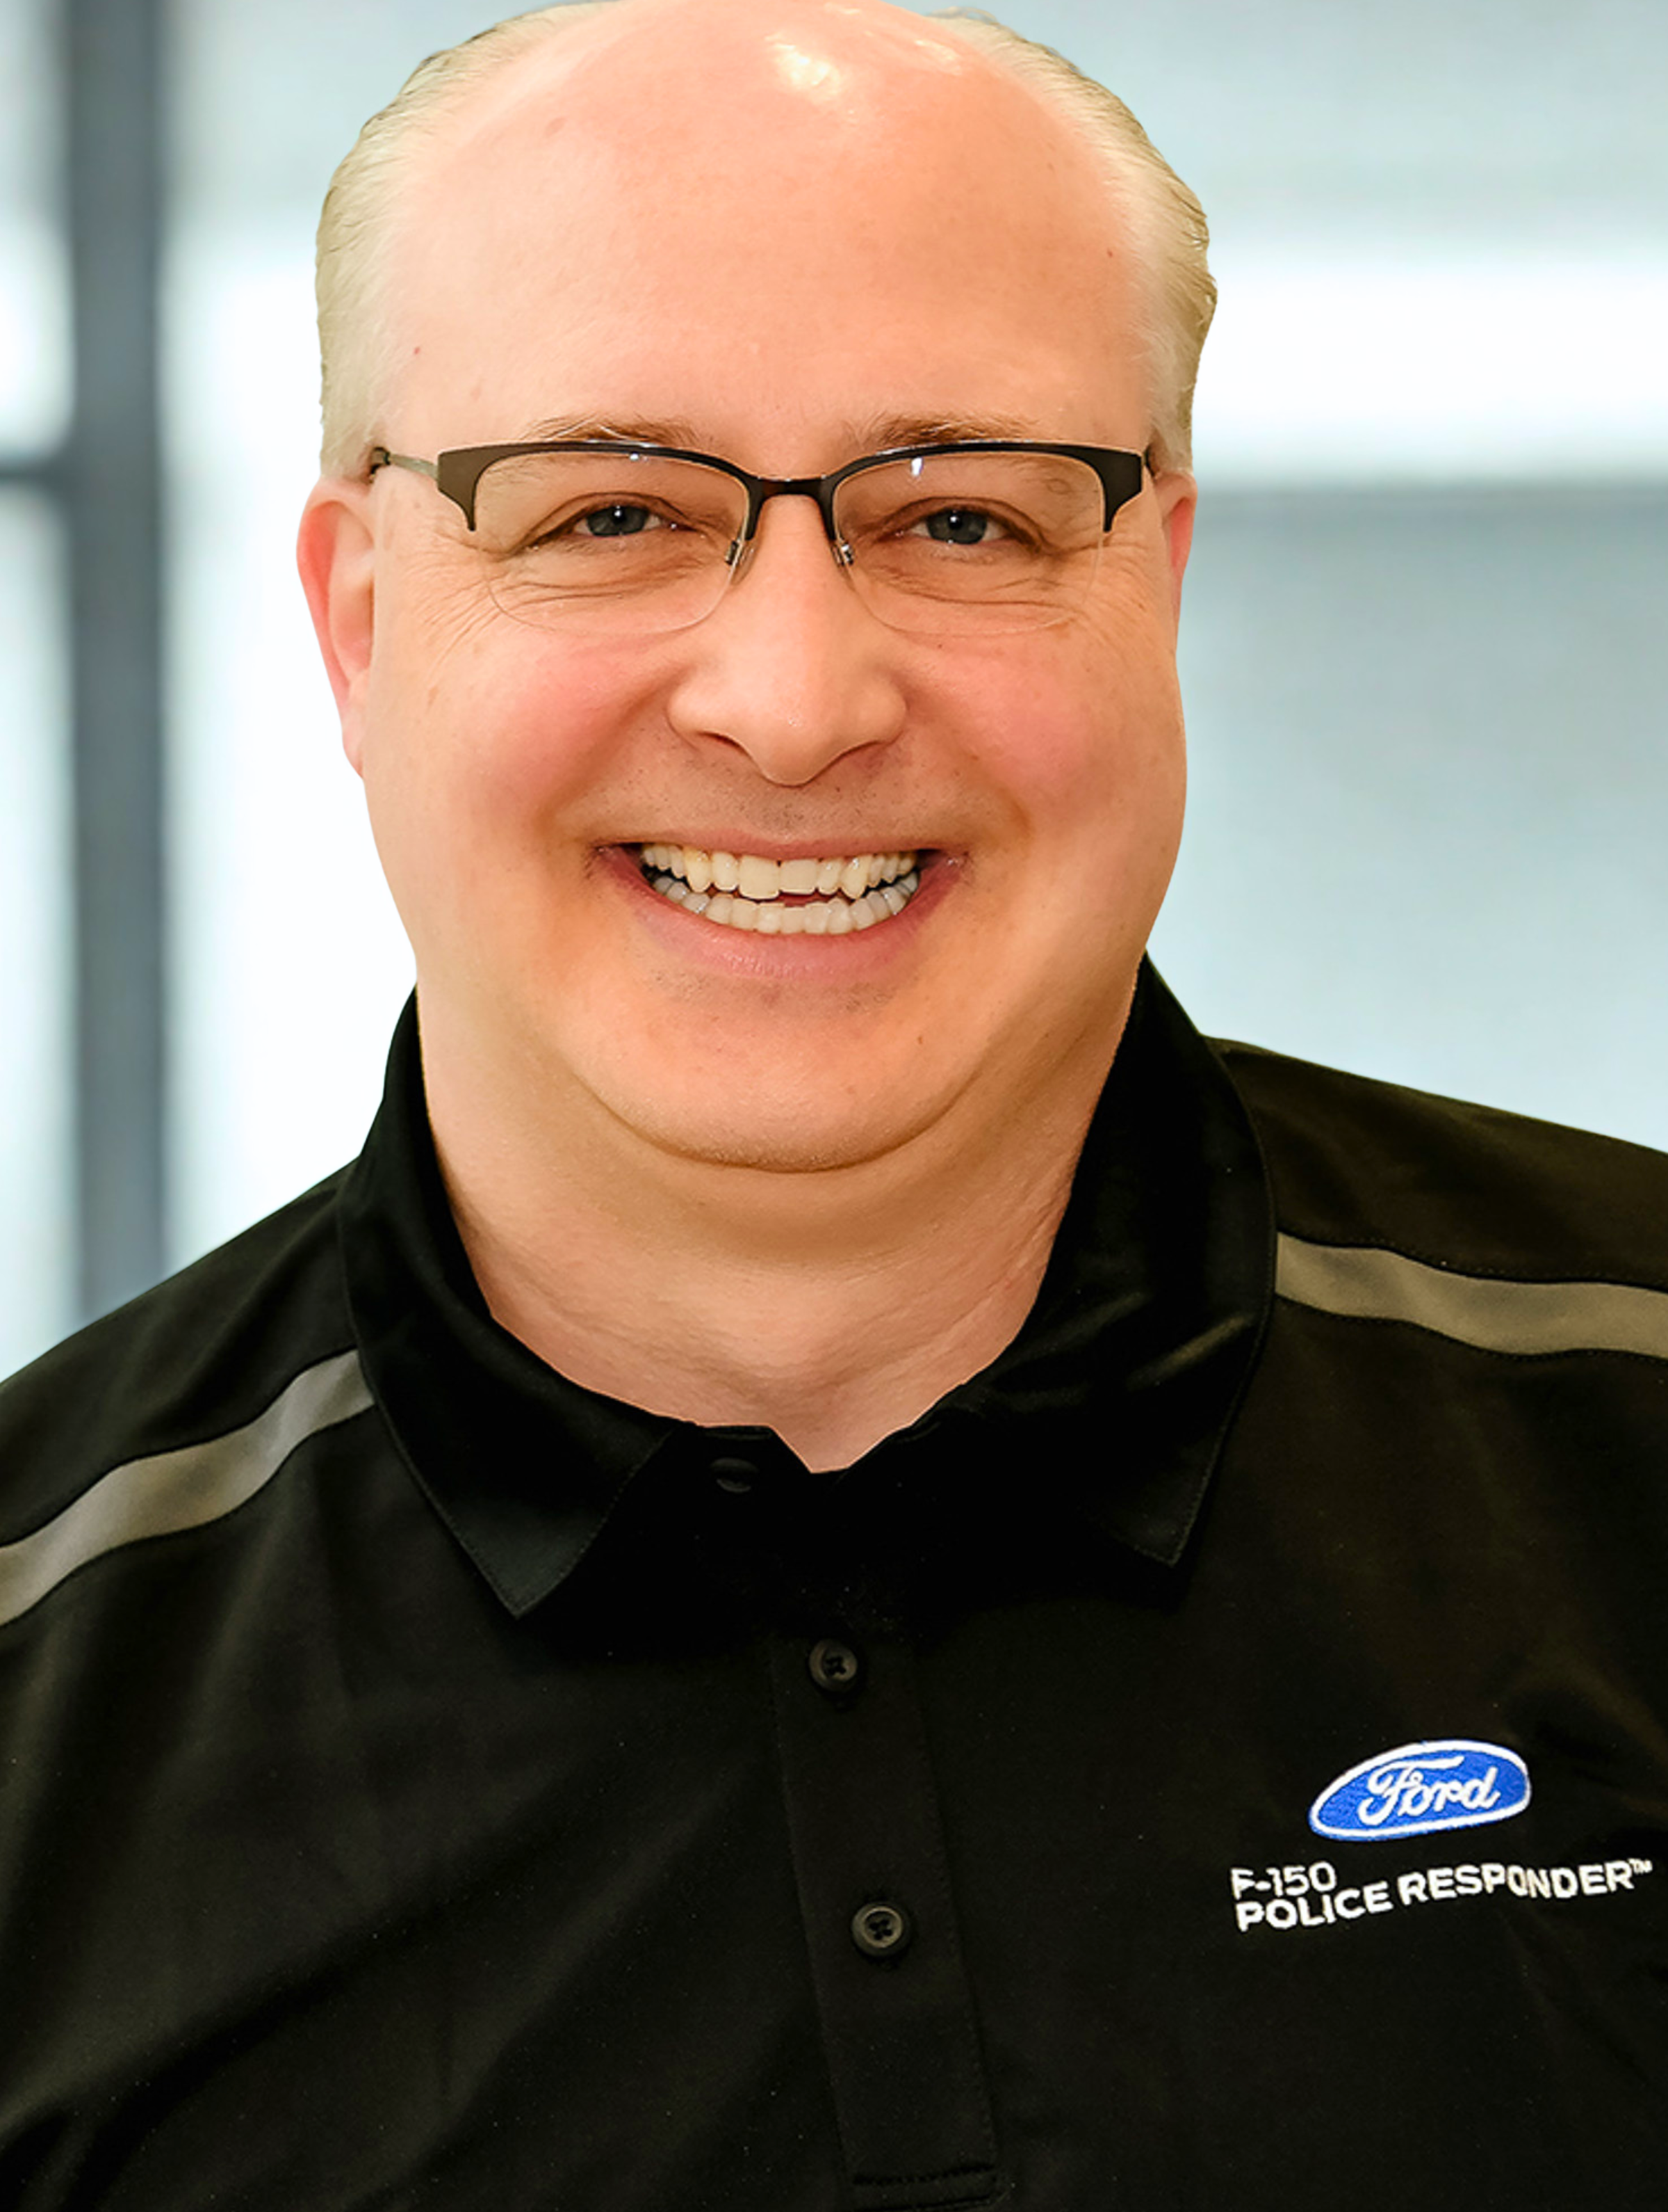 | Daniel Mazurek  Northeast Government Sales Manager  Ford Pro
Daniel Mazurek has worked at Ford Pro for more than 28 years. He has held several roles within the company in its sales and service divisions. For the past eight years, he has served as Northeast Government Sales Manager.
Dan lives in Northwest Philadelphia with his wife of 30 years. He travels throughout the 11-state Northeast region and enjoys meeting with government agency fleet teams.
________________________________________________________________________________
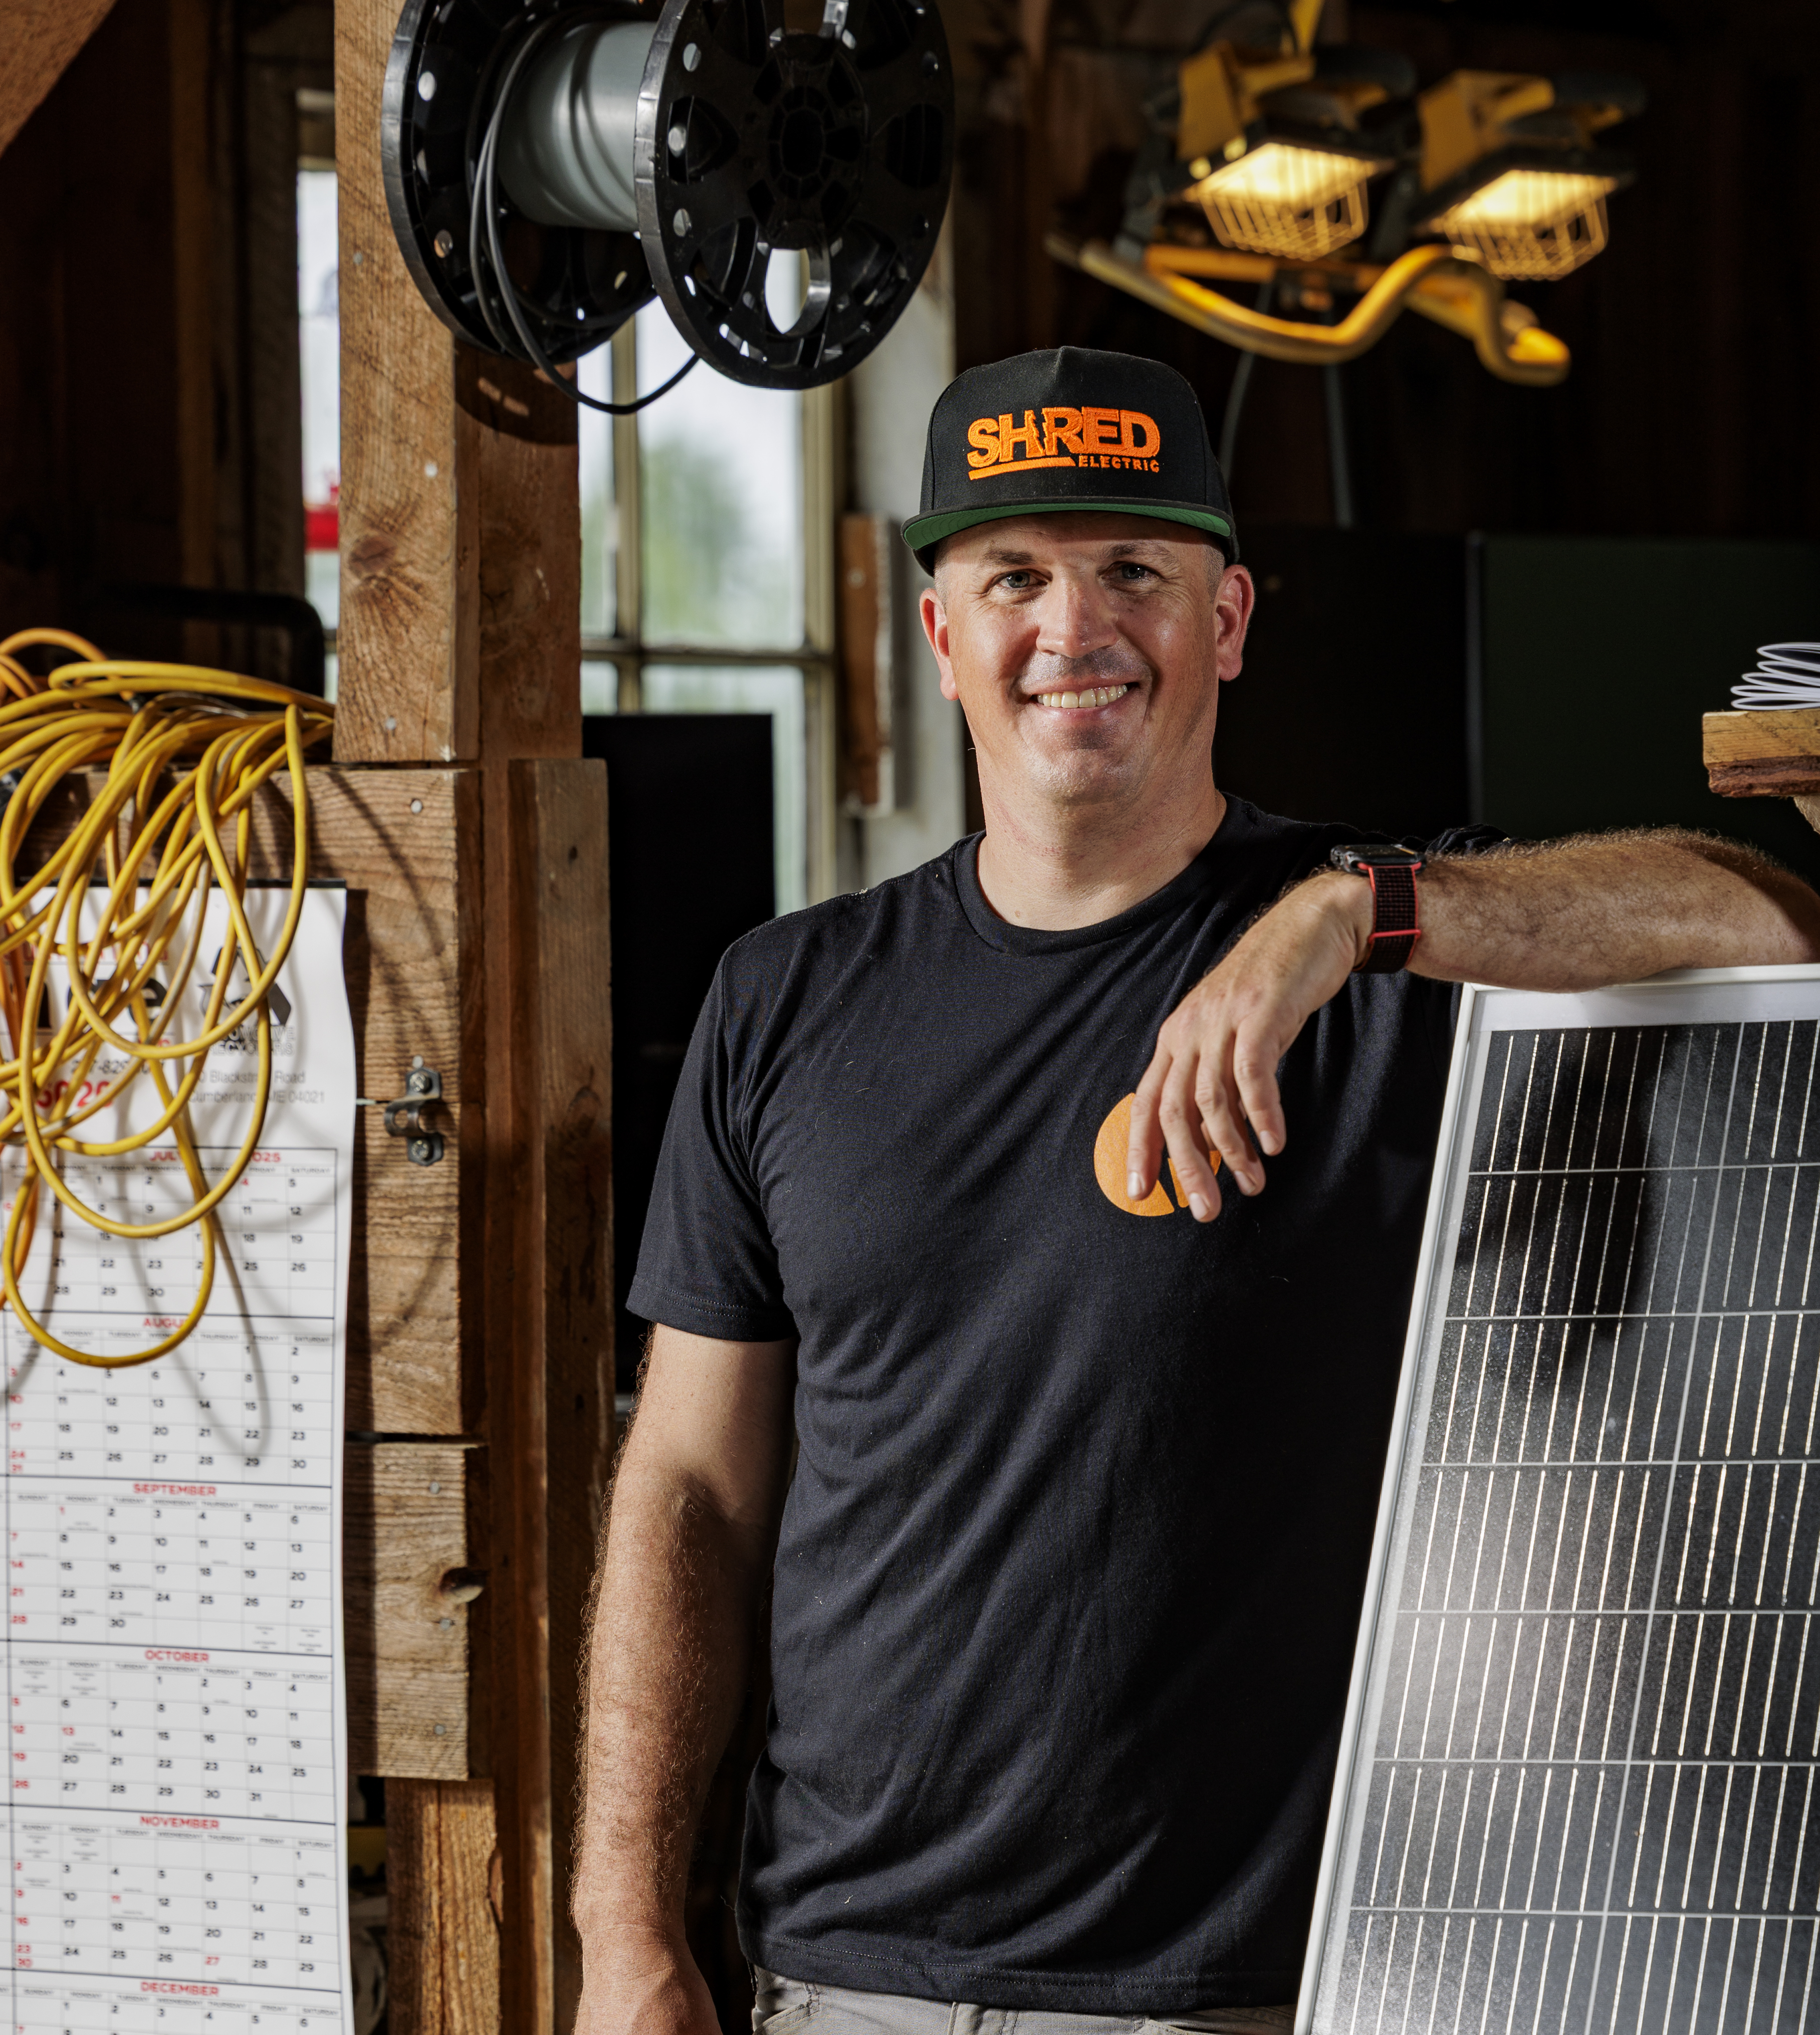 | Nick Planson  Founder & CEO  Shred Electric
Nick Planson is the Founder & CEO of Shred Electric, a Maine-based innovator delivering carbon-neutral power solutions for the marine, agriculture, and off-road vehicle industries. He is also a supporting founder of The Boat Yard, LLC and Co-Founder of the Sea Meadow Marine Foundation.
A serial entrepreneur with a background in clean energy, electric vehicle integration, and international IT, Nick has scaled companies, supported successful exits, and now leads projects replacing fossil fuel infrastructure with solar, battery, and wind-powered systems. He is committed to advancing equity, sustainability, and economic resilience across the food, farming, and marine supply chains.
________________________________________________________________________________
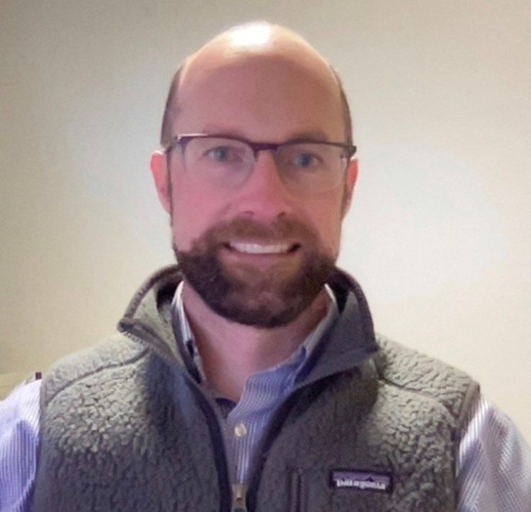 | Hugh Reece  Senior Program Manager, Fleet EV Programs  National Grid
Hugh Reece is a Senior Program Manager dedicated to supporting National Grid's Fleet EV Programs in Massachusetts. Hugh is an accomplished professional with expertise in cleantech, program management, and enterprise client management.
Before joining National Grid, Hugh worked at Volta Charging, where he provided support to sales and operations teams. Prior to Volta Charging, he worked at Modivcare, managing a portfolio of enterprise clients. He also spent time at Enel (formerly EnerNOC), where he implemented both its suite of energy management services and Demand Response programs.
He resides in Medford, Massachusetts, with his wife and two children. Outside of work, you'll find him spending time with family, mountain biking in the warmer months, and skiing as much as he can in the winter.
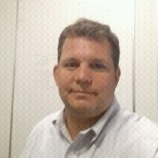 | Bill Scott  Software Architect & Technology Consultant  CloudZoom Solutions
Bill Scott is a software architect and technology consultant with extensive experience applying IoT, data, computer vision, and AI technologies to vehicles and fleet operations. His work has included processing telemetry from fuel-delivery fleets at Civacon, developing computer-vision technology for Chief to identify vehicle hail damage, and building systems at Sentric ADAS to help ensure ADAS systems are properly configured and calibrated.
Most recently, Bill has focused on practical applications of AI, including developing an AI-assisted proof-of-delivery platform at a New York City food delivery service that replaced OptimoRoute, saving approximately $30,000 annually. Through CloudZoom Solutions, he explores how AI and agentic systems can turn the growing amount of fleet data into better operational decisions.
________________________________________________________________________________
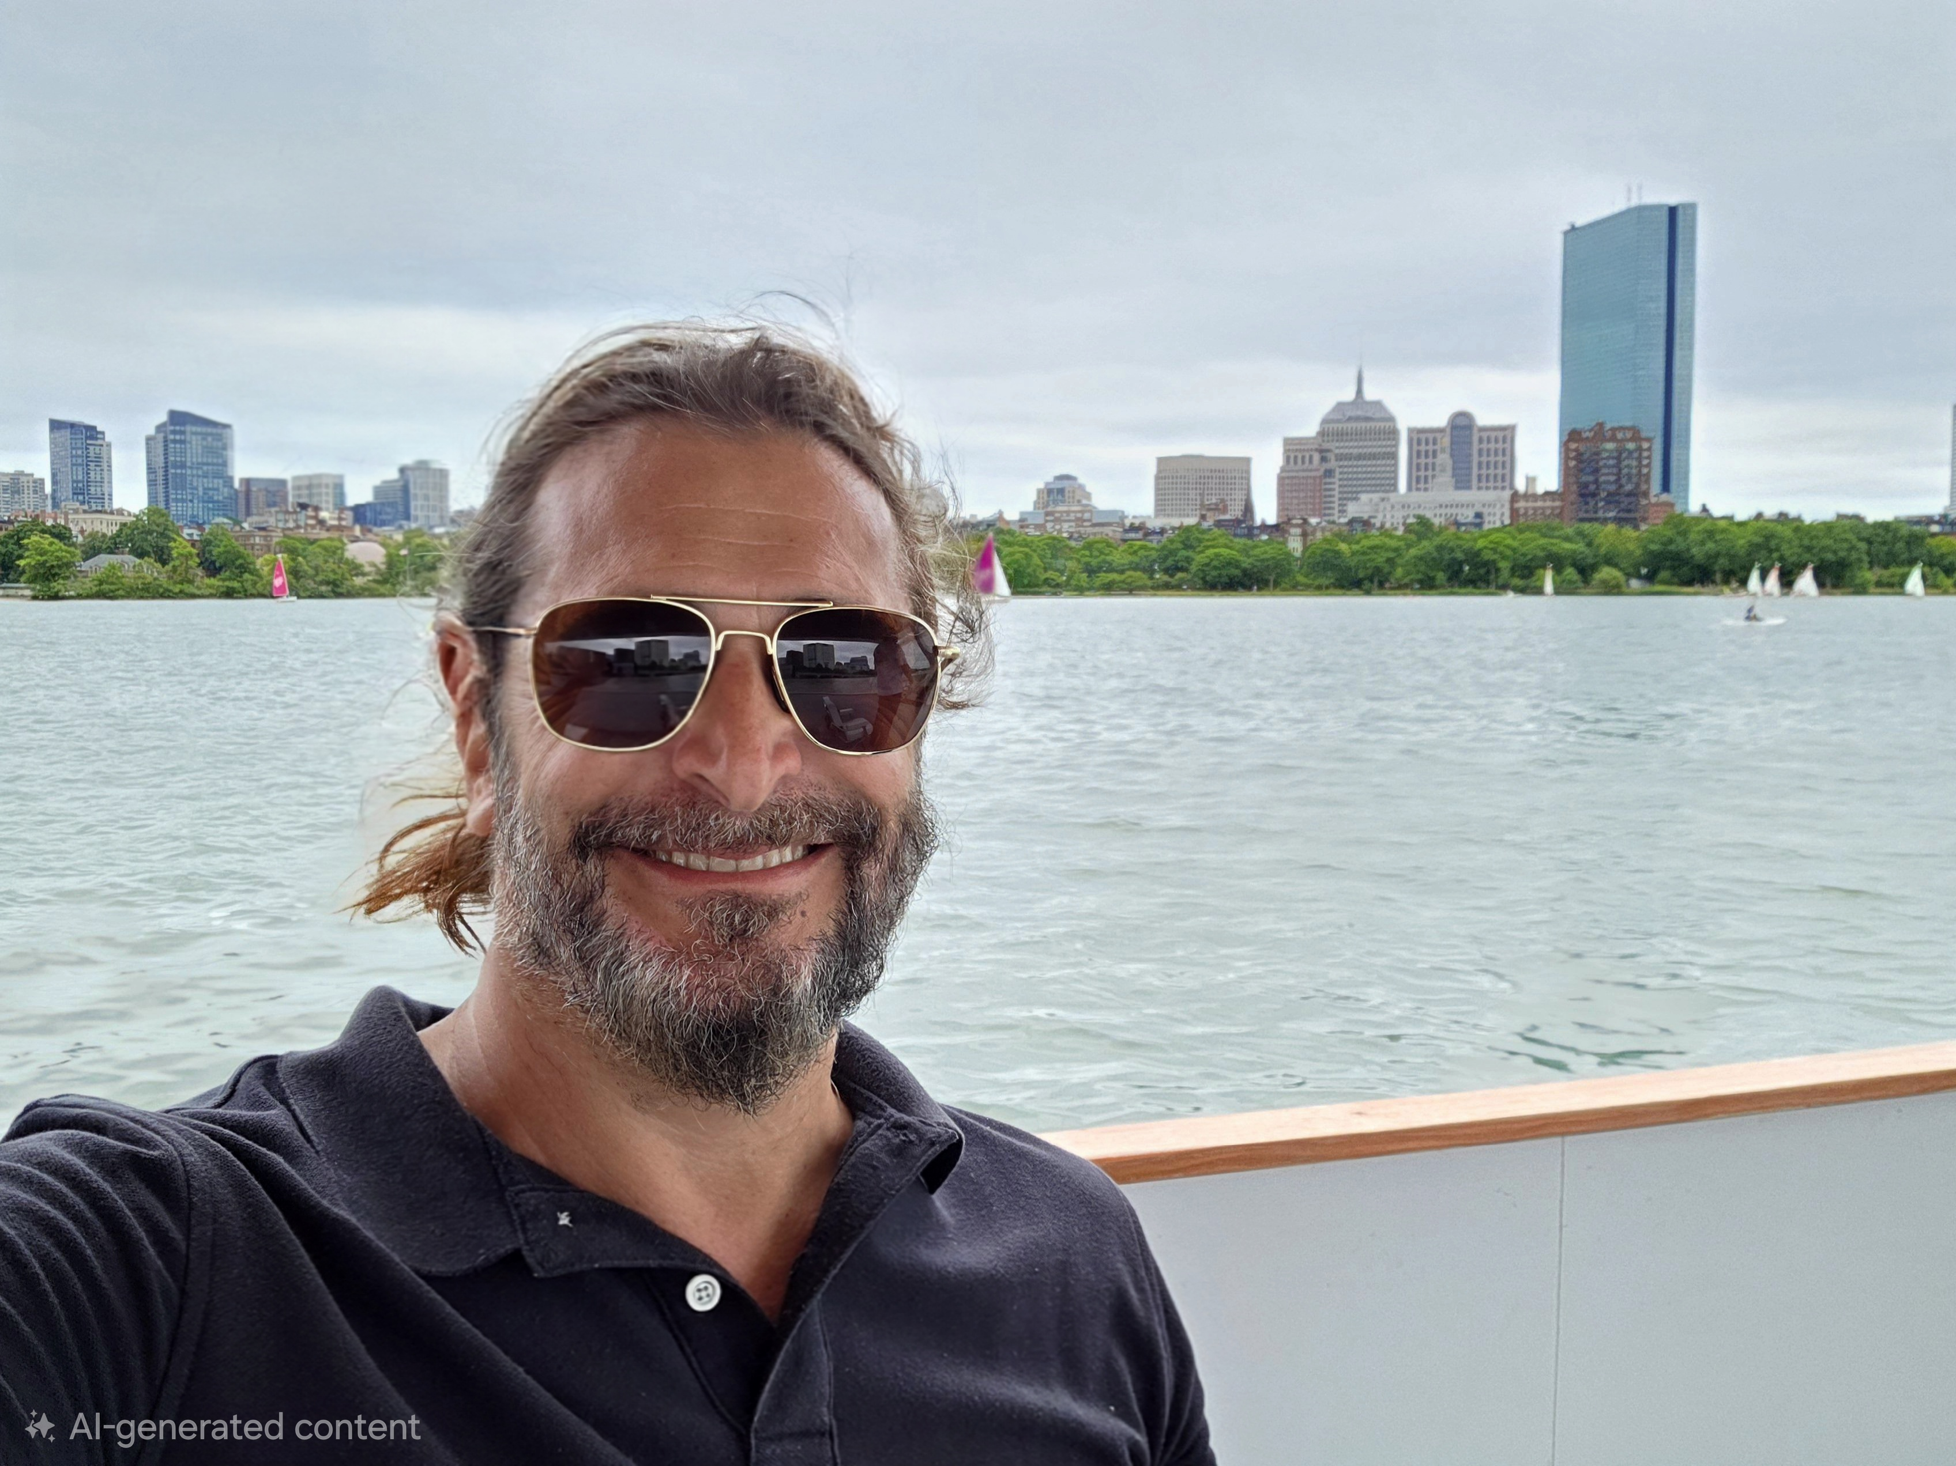 | Drew Rollert  Founder  Wada Hoppah
Drew Rollert is the founder of Wada Hoppah, the first electric ferry on the East Coast, the first commercial ferry and commuter ferry service on the Charles in 100 years, and the first zero-emissions, wakeless, shallow-draft inland marine transportation service in the United States. Drew is determined to improve Boston and MetroWest's transportation options, remove cars from congested roads, and restore ferry services to the Charles in a climate-supportive and healthy way.
Originally from Cape Cod, he grew up appreciating healthy marine ecosystems and their contribution to our lives. As a long-time entrepreneur, Drew has brought several game-changing technologies and services to life with software and software-based communities.

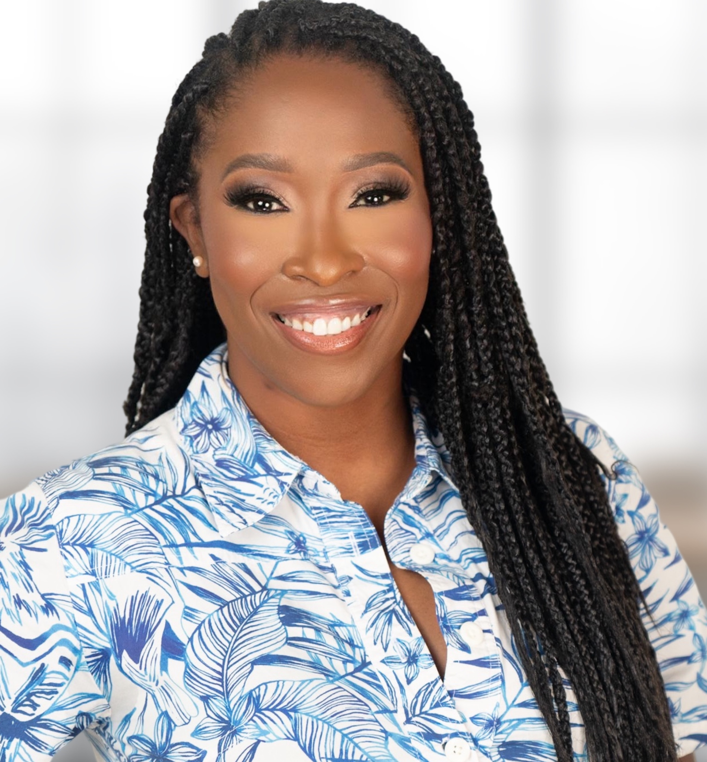) | Kameale C. Terry  Co-Founder & CEO  ChargerHelp!
Kameale C. Terry is the co-founder and CEO of ChargerHelp!, a cutting-edge technology company launched in 2020 that tackles the issue of inoperable electric vehicle (EV) charging stations. A native of South Central Los Angeles, Kameale is driven by her passion for data, technology, and community empowerment. Under her leadership, ChargerHelp! has raised over $21 million, amassed the nation's largest dataset of EV service work orders, and services stations across 17 states.
Kameale's innovative approach blends real-world data, predictive analytics, and machine learning to provide industry-leading solutions to ensure EV charging reliability. She is also deeply committed to workforce development, helping to create high-paying jobs through partnerships with organizations like the Society of Automotive Engineers and the U.S. Department of Labor. Her background in operations and technology, combined with her commitment to empowering historically marginalized communities, has positioned her as a thought leader in the clean energy and mobility sectors.
________________________________________________________________________________
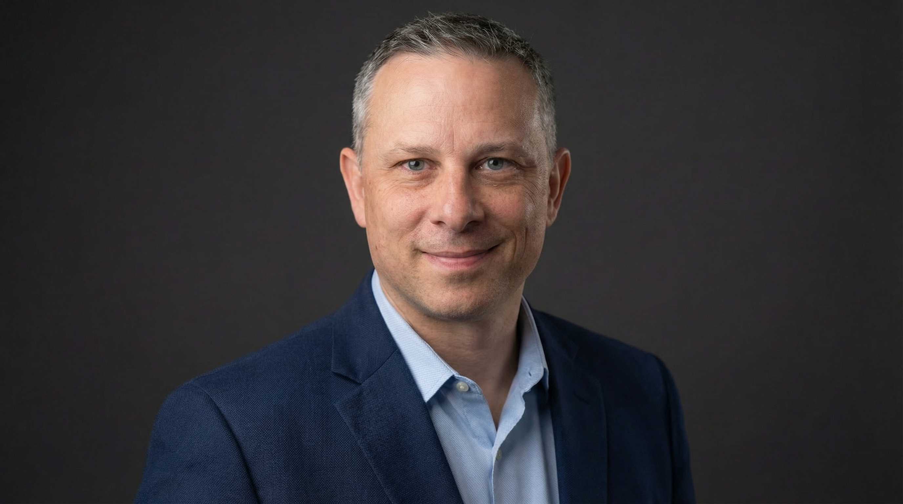 | Adam Wint  Commercial Insights Manager, APP&R  Ford Pro
Adam Wint is a forward-thinking market strategist and the Head of the Ford Pro Consumer Insights team which specializes in decoding complex business behaviors and needs to guide current and future strategy and product plans. Known for his capability to synthesize high-level data with qualitative fieldwork, Wint helps Ford navigate the shift between present operations and future market disruption.

